Lab 1

1. What is an ENVI Header File and what is its purpose?

It is a file that contains the metadata for ENVI type images. It is created any time a picture is saved to raster format and has the same name.

1. What is the required and optional information in an ENVI header file?

The required information in an ENVI header file is listed below:

* Samples
* Lines
* Bands
* Offset
* File Type
* xstart/ystart
* Data Type
* Byte Order
* Interleave

3. What are the ENVI directly supported output file formats – e.g., in what data formats can ENVI directly save data. Which of these are raster and which of these are vector?

You may output save data in the following formats:

* ArcView Raster Files
* ER Mapper Files
* IMAGINE Files
* JPEG 2000 Files
* NITF Files
* PCI Files
* TIFF Files
* .txt files

4. Display the Landsat ETM+ image (downtown.img) of Houston, Texas a as false Color composite image by using the RGB color display and displaying band 4 as red, band 3 as green and band 2 as blue. You should demonstrate your success with this by pasting the downtown Houston portion of the image into your lab report.

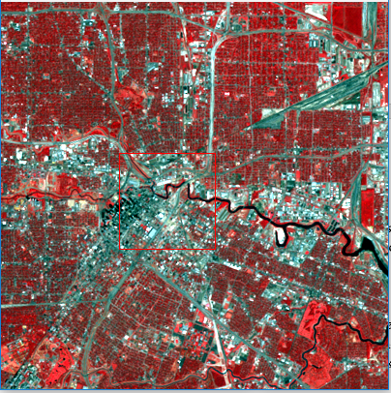

Question 5. How many bands, rows (lines) and columns (samples) does the multi-spectral data set “downtown.img” have? What are the pixel depth (bits or byte per pixel) and spatial resolution (cell size)? What is the band label for each data layer?

This image has 3 bands, 627 Samples, 517 Lines, a pixel depth of 1 and a cell size of 30m.

6. What is the datum and map projection of the panchromatic Landsat image “houston_pan.img”? What is the geographic location of the top left corner of this image? What is the total geographic area covered by this image in square kilometers?

The datum of the panchromatic image is WGS84, while its map projection is UTM Zone 15N. The geographic location of the top left corner is 267300.00E, 3300780.00N, and the image covers a total of 144 square km.